Connect to Jenkins for the initial configuration

1.After installation, open a browser and connect to it. The default port of Jenkins is :8080, therefore on your local machine you find it under the following URL:

http://localhost:8080/

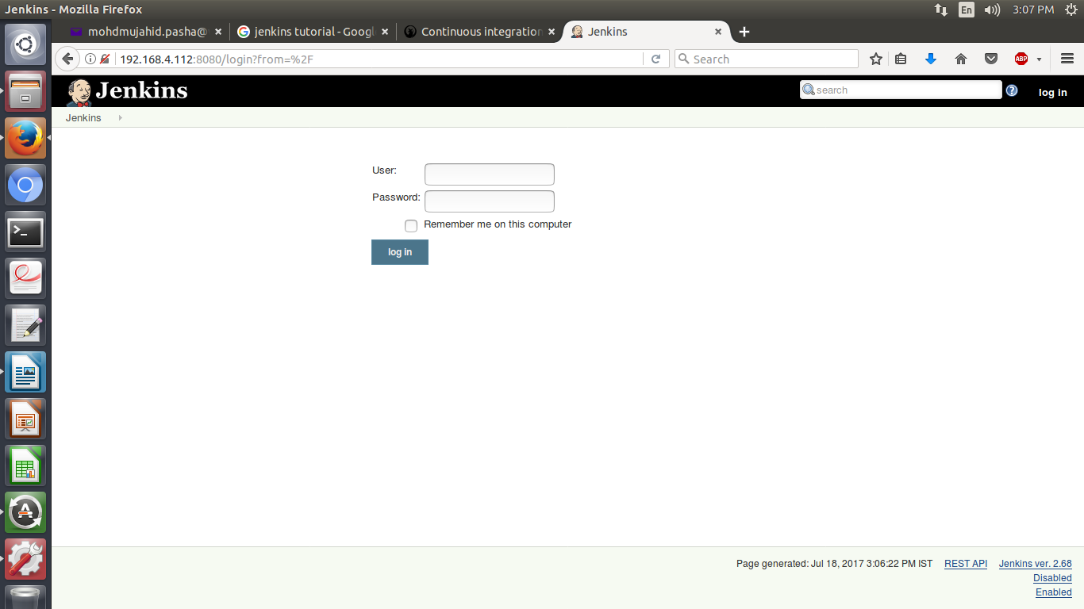

On the login page, select Create an account to create the users you just gave access.

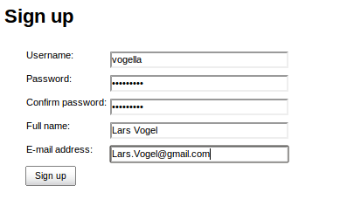

Enter a description for the job and configure how many old jobs should be retained.

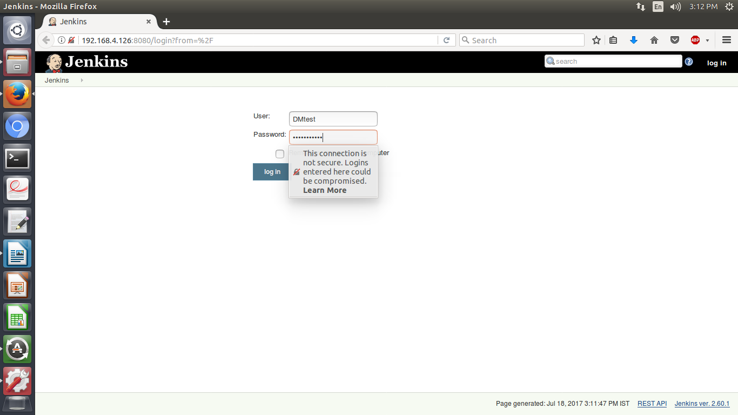
Sign In

Generate ssh key for Jenkins userAfter a while the job should go to green or blue (depending on your configuration), if successful. Click on the job and afterwards on Console Output to see the log file. Here you can analyze the build errors.
If you want to access a private Git repo, for example at Github, you need to generate an ssh key-pair. Create a SSH key with the following command.

$sudo -u jenkins ssh-keygen

The public key must be uploaded to the service you are using, e.g., Github.

Jenkins management

Plug-in management
To install plugins in Jenkins select use the Manage Jenkins ▸ Manager Plugins link and search for the plugin you want to install. Select it from the list and select to install it and restart Jenkins.

Restart your Jenkins
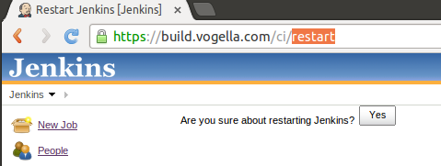

Setting up a Jenkins job

The build of a project is handled via jobs in Jenkins. Select New Item. Afterwards, enter a name for the job and select Freestyle Job and press OK.
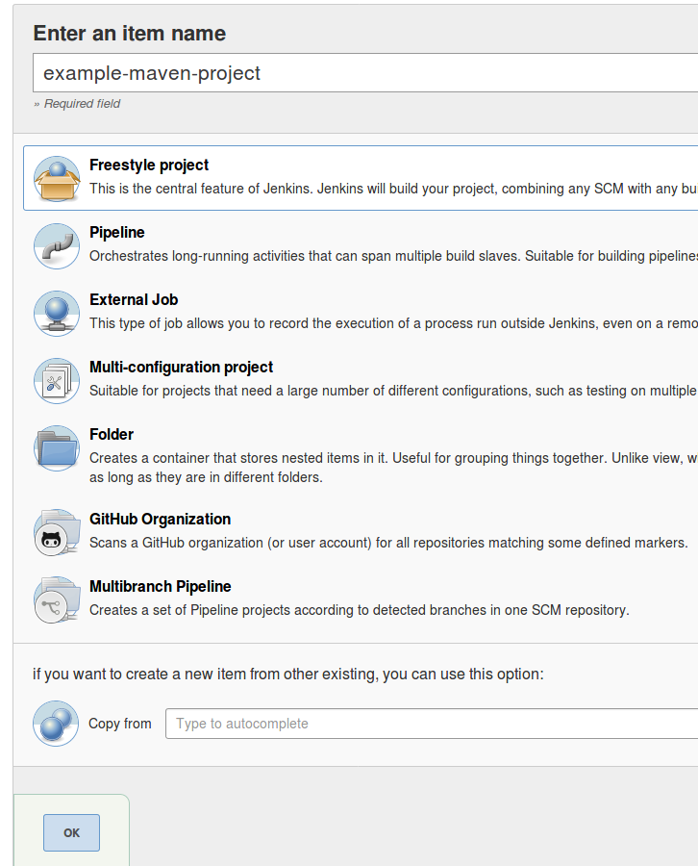

Enter a description for the job and configure how many old jobs should be retained.

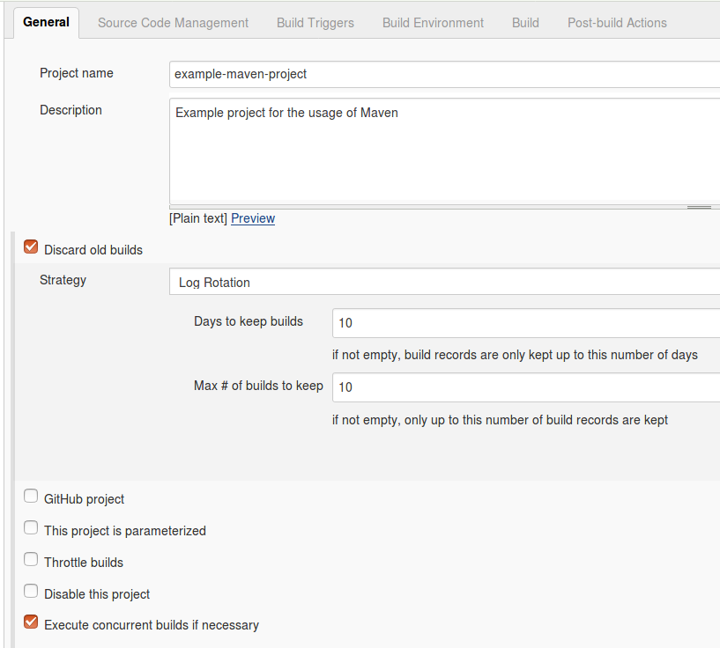

Configure how the source code can be retrieved. If you for example using Git, enter the URL to the Git repository. If the repository is not public, you may also need to configure the credentials.

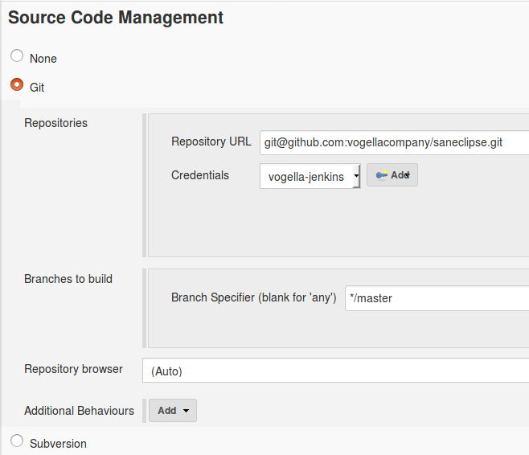

Specify when and how your build should be triggered. The following example polls the Git repository every 15 min. It triggers a build, if something has changed in the repo.

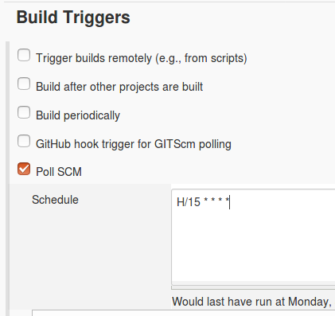

I typically delete the workspace before a build to avoid any side-effect. In the Build section you can add a build step, e.g., a Maven build.

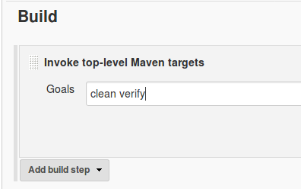

Enter the commands to run Batch files to run
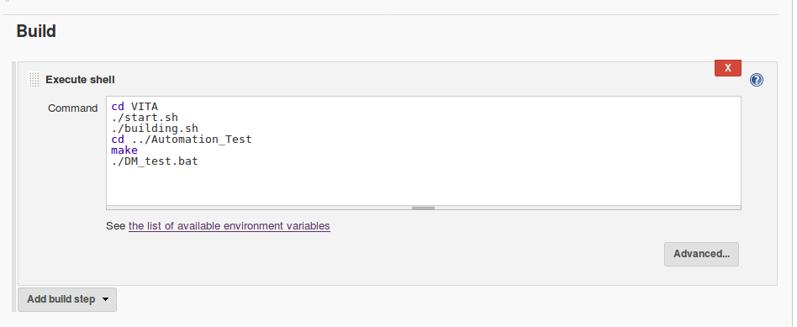
Press Apply and Save to finish the job definition. Press Build Now on the job page to validate the job works as expected.
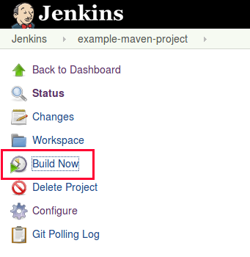

After a while the job should go to green or blue (depending on your configuration), if successful. Click on the job and afterwards on Console Output to see the log file. Here you can analyze the build errors.

For mail configuration setup

Select Manage Jenkins from jenkins home page

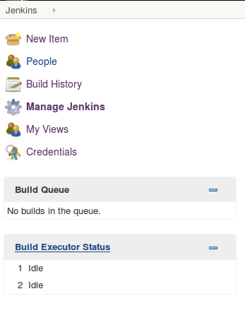

Go for Configure System

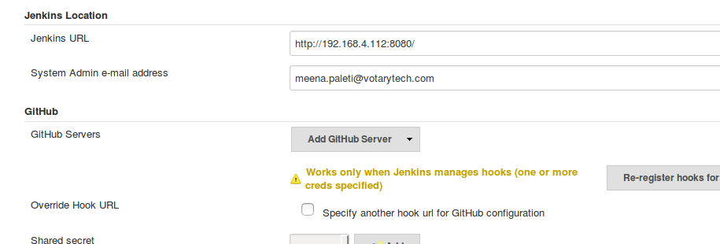
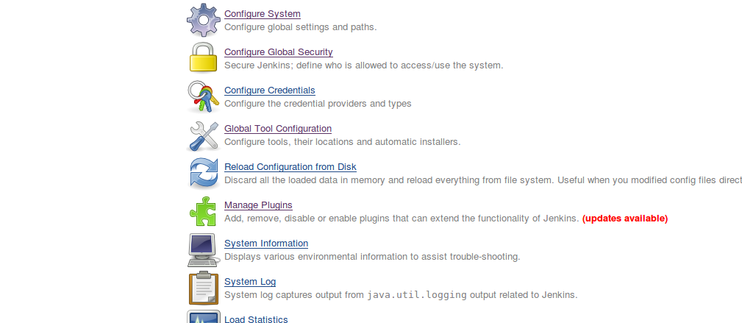

Find the Extended e-mail Notification ,E-mail Notification and enter the required details.

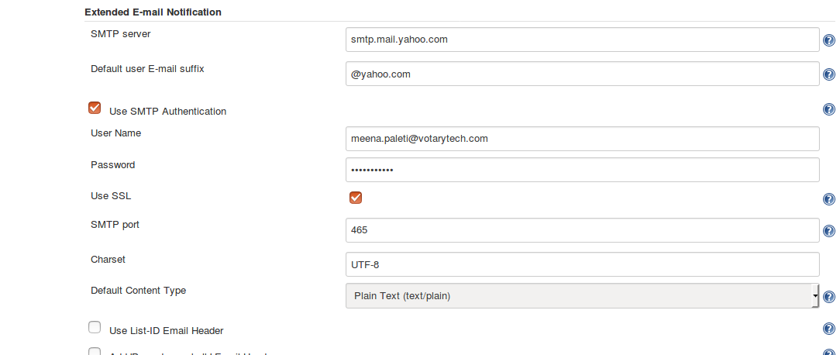
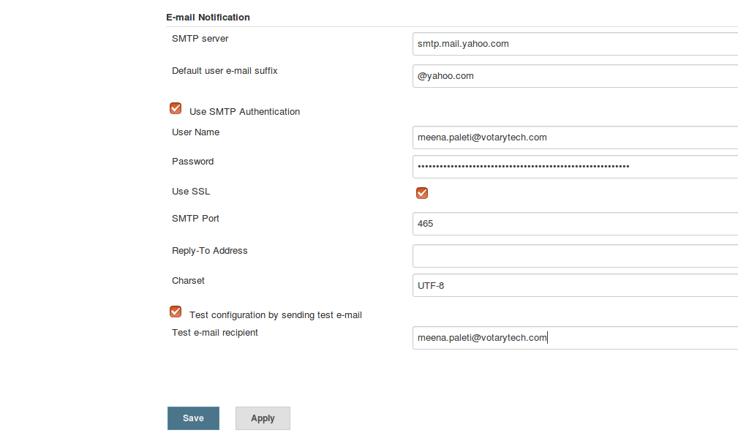
Enter your mail id and password ,you will find in Advance settings

Press Apply and Save

To add the email ID
Go back to project

select configure ->post build Actions->add post build action->select Email notification and Editable email notification.

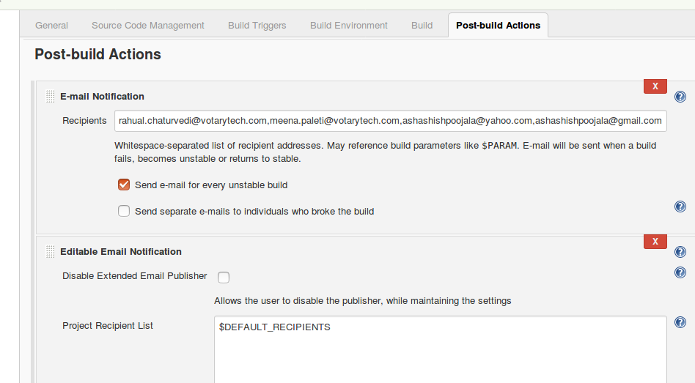

Select add trigger to add more triggering options and go for advance settings to add mail-id for different domian(Developer /Tester /reception list etc)
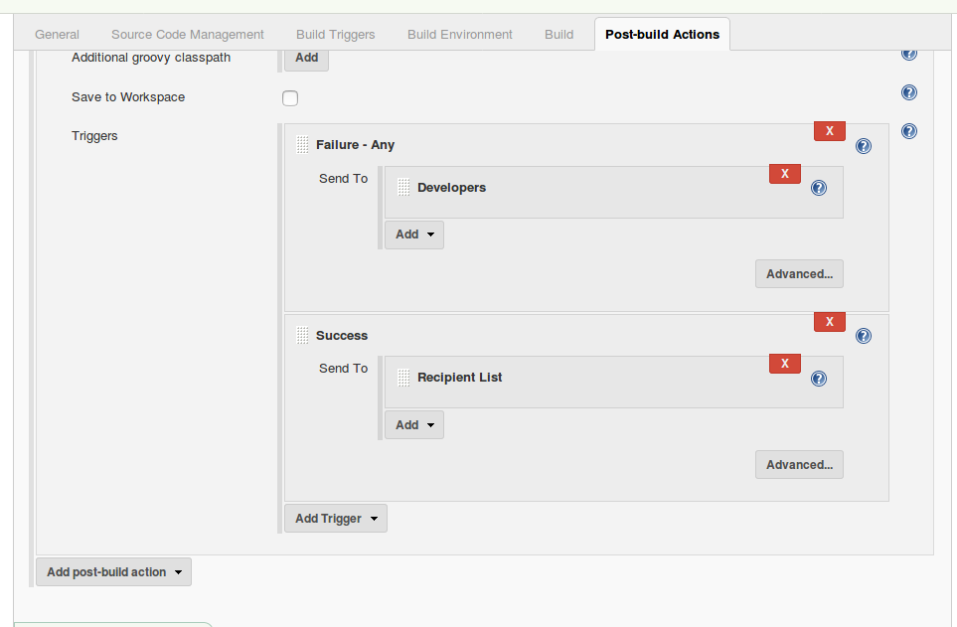
Press Apply and Save

